# Name: Period: Date:

# 

**Understanding God’s Ongoing Creation.**

**The Theory of Evolution**

Recall some concepts:

1. **What is the theory of evolution?** When did the theory originate?
2. Is evolution a theory or a law?

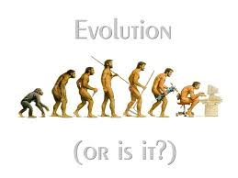

1. Does evolution disprove God?